STANDARD FORMAT OF “LEHENGA DESCRIPTION”


For Online Selling Products
Design Name: SATRANGI-B
Product Colours NO.: B4
.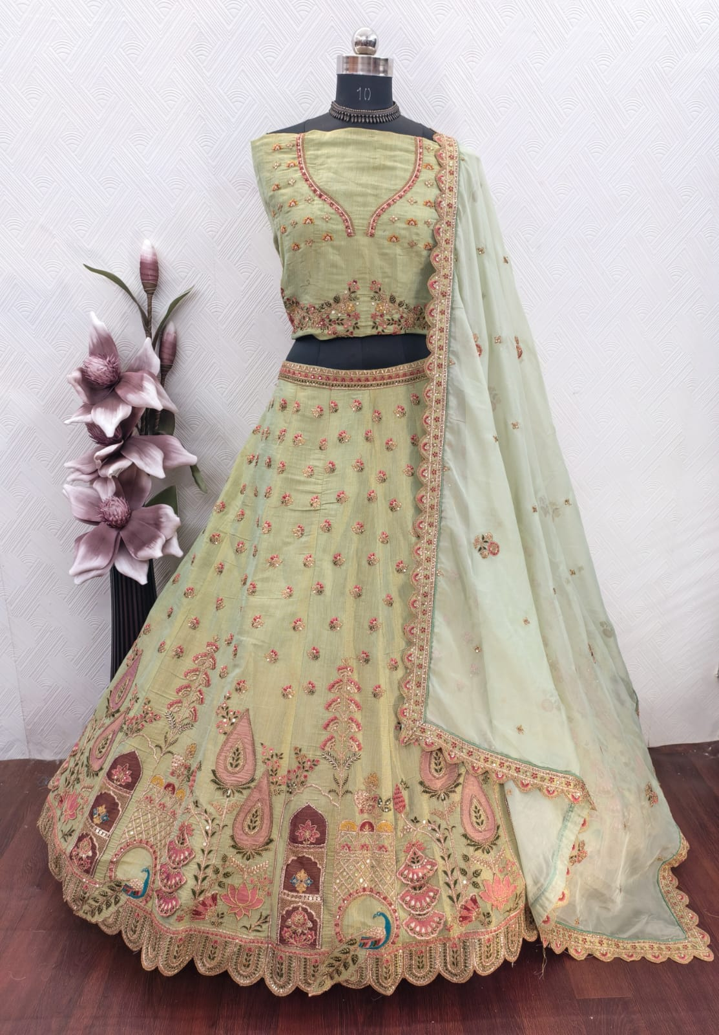.
Particulars | Details
Lehenga Fabric | Jharkan Silk
Blouse Fabric | Jharkan Silk
Dupatta Fabric | Tebi Dupatta
Work Type | Jari, Jarkan & Thread embroidery Work
Colour | Pista
Pattern | Heavy Girlish
Stitching Type | Semi-Stitched (Can be customized up to 44")
Occasion | Reception, Engagement & Festive Wear
Fit Type | Regular Fit
Care Instructions | Dry Clean Only
Package Contents | 1 Lehenga, 1 Blouse Piece, 1 Dupatta

KEY HIGHLIGHTS
- Crafted from premium Jharkan silk fabric that offers a rich texture and elegant finish
- Beautifully enhanced with fine Zari and thread embroidery for a refined festive look
- Paired with a graceful Tebi dupatta that adds charm and sophistication
- Perfect choice for festive wear, receptions, and special celebrations
- Semi-stitched design allows easy customization up to size 44
- Lightweight yet grand, ensuring comfort during long hours of wear
- A seamless blend of traditional craftsmanship with modern ethnic styling

